1. Spring Data JPA - Quick Example

package com.cognizant.ormlearn;

import java.util.List;

import org.slf4j.Logger;

import org.slf4j.LoggerFactory;

import org.springframework.boot.SpringApplication;

import org.springframework.boot.autoconfigure.SpringBootApplication;

import org.springframework.context.ApplicationContext;

import com.cognizant.ormlearn.model.Country;

import com.cognizant.ormlearn.service.CountryService;

@SpringBootApplication

public class OrmLearnApplication {

private static final Logger LOGGER = LoggerFactory.getLogger(OrmLearnApplication.class);

private static CountryService countryService;

public static void main(String[] args) {

ApplicationContext context = SpringApplication.run(OrmLearnApplication.class, args);

LOGGER.info("Inside main");

countryService = context.getBean(CountryService.class);

testGetAllCountries();

}

private static void testGetAllCountries() {

LOGGER.info("Start");

List<Country> countries = countryService.getAllCountries();

LOGGER.debug("countries={}", countries);

LOGGER.info("End");

}

}

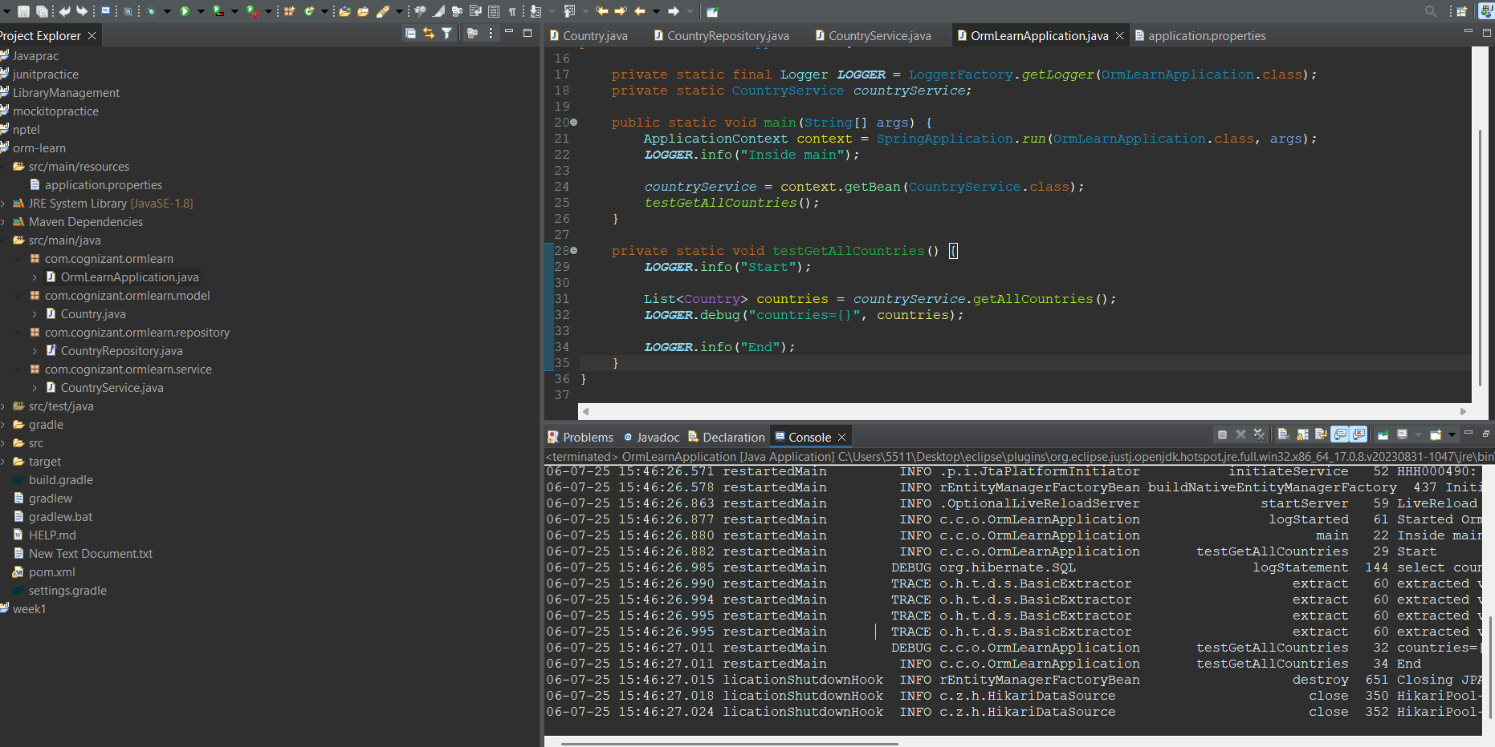

1. Difference between JPA, Hibernate and Spring Data JPA

**Hibernate**

/* Method to CREATE an employee in the database */

public Integer addEmployee(Employee employee){

Session session = factory.openSession();

Transaction tx = null;

Integer employeeID = null;

try {

tx = session.beginTransaction();

employeeID = (Integer) session.save(employee);

tx.commit();

} catch (HibernateException e) {

if (tx != null) tx.rollback();

e.printStackTrace();

} finally {

session.close();

}

return employeeID;

}

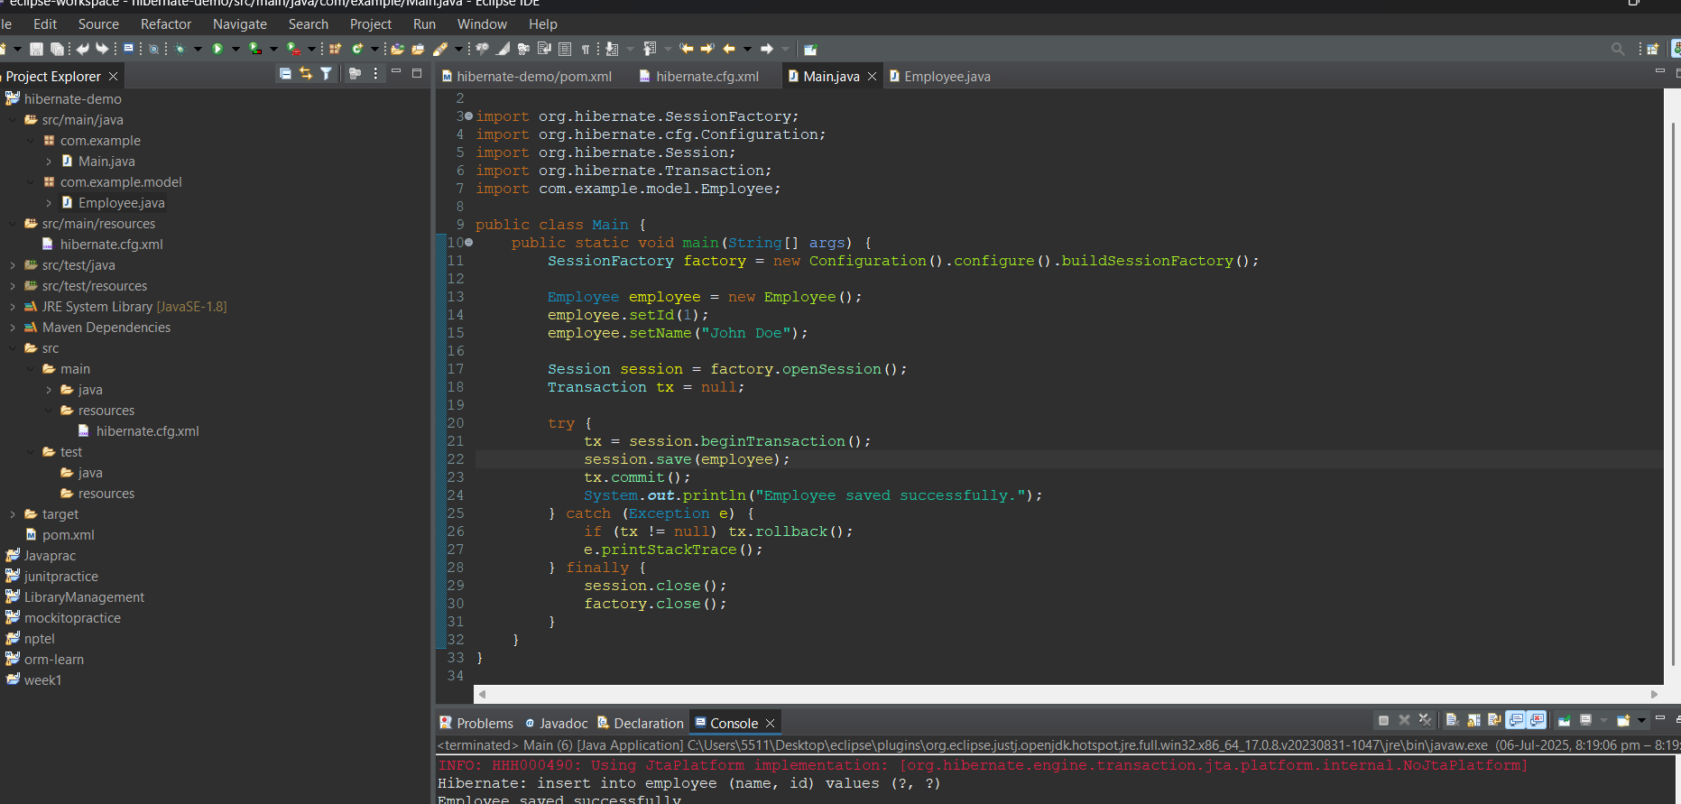

Spring Data JPA

EmployeeRespository.java

public interface EmployeeRepository extends JpaRepository<Employee, Integer> {

}

EmployeeService.java

@Autowire

private EmployeeRepository employeeRepository;

@Transactional

public void addEmployee(Employee employee) {

employeeRepository.save(employee);

}

